**Homework 7: SOC System Integration**

**Issued:** April 25th (Tuesday), 2023 **Due:** May 01st (Monday), 2023

**What to turn in**: **Copy the text from your MODIFIED codes and paste it into a document**. If a question asks you to plot or display something on the screen, also include the plot and screen output your code generates. Submit either a *.doc or *.pdf file.

**\*\*\*\*\*\*\*\*\*\*\*\*\*\*\*\*\*\*\*\*\*\*\*\*\*\*\*\*\*\*\*\*\*\*\*\*\*\*\*\*\*\*\*\*\*\*\*\*\*\*\*\*\*\*\*\*\*\*\*\*\*\*\*\*\*\*\*\*\*\*\*\*\*\*\*\*\*\*\*\*\*\*\*\*\*\*\*\*\*\*\*\*\*\*\*\*\*\***

**Problem 1 (10p): LCD Drive Interface**

Implement an AHB interface of the LCD Drive and integrate it into the top system. Please see the description in the lecture note for details.

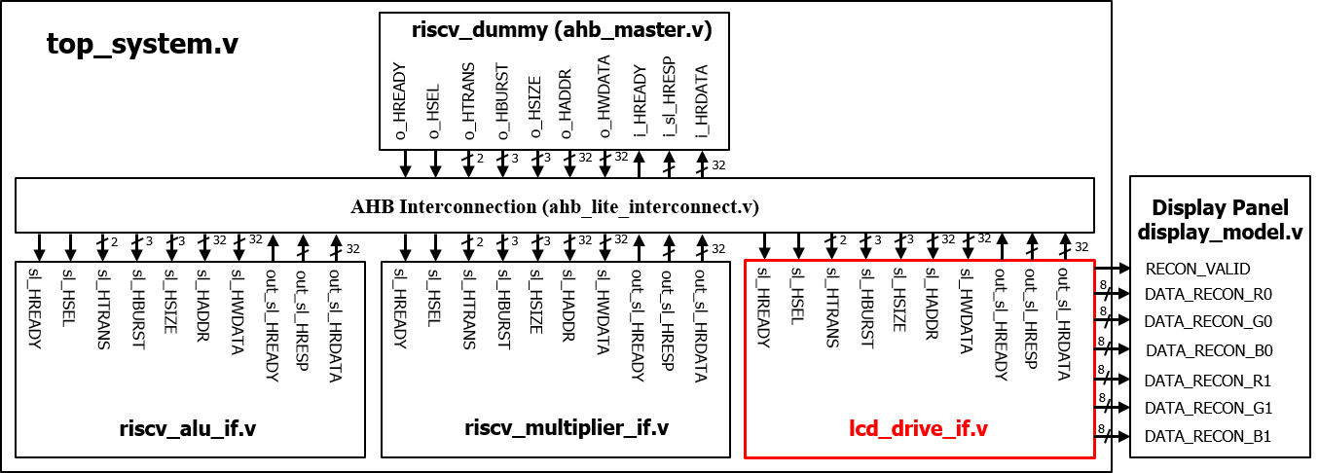

Fig. 1-1: A top system using an AHB bus.

What you have to do:

1. **Create a custom IP (lcd_drive_if.v) and add it to the top system**

* Complete the code to create the AHB slave interface of the LCD drive (lcd_drive_if.v).
* Add its base address and the register map (map.v).
* Complete the code to add the LCD drive IP to the Bus interconnect (top_system.v).
* Do a simulation with time = 5.000 ns.
* Capture the simulation result, i.e., waveform.

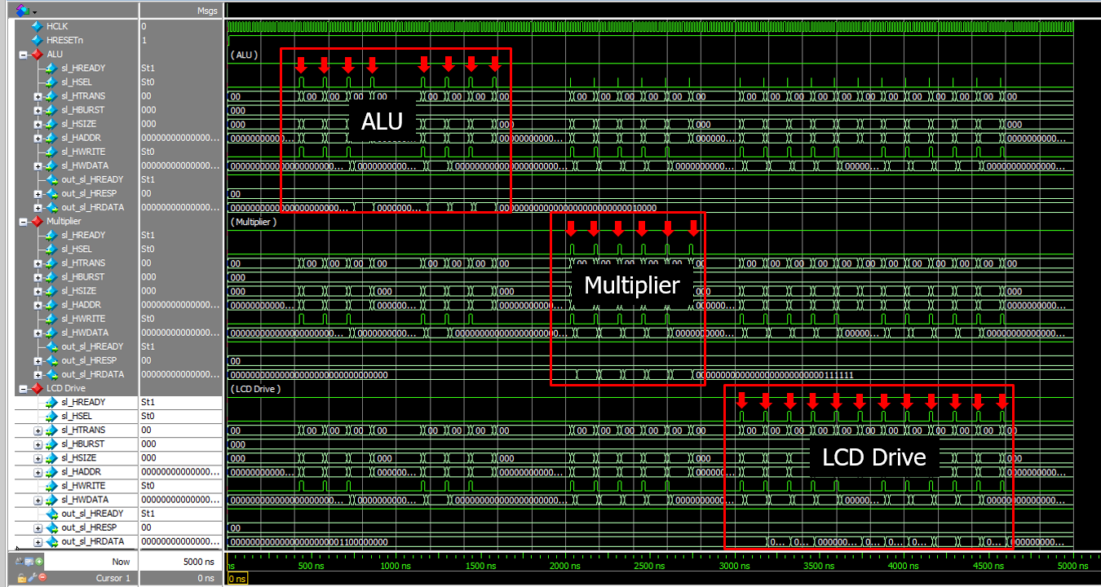

Fig. 1-2: Waveform with highlighted Select signals of three AHB slaves.

1. **Generate data signals (lcd_drive_if.v)**

* Complete the missing codes for the finite state machine FSM, such as row and column counters and the end-of-frame signal.
* Do a simulation with time = 6 ms.
* Test the system with different brightness modes.
* Capture the results, including the waveform and the output images.

**Submit your RTL codes**.



Fig. 3-2: Simulation results.

**Solution 1**

**(a) Create a custom IP (lcd_drive_if.v) and add it to the top system**

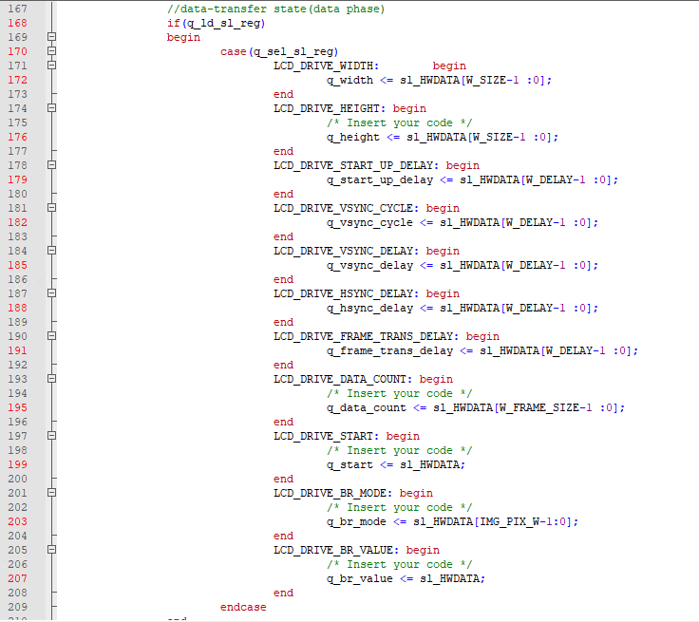

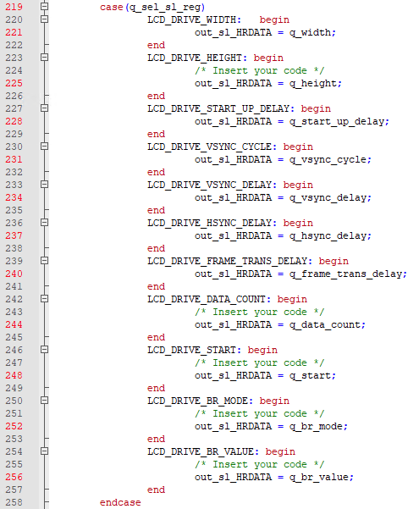

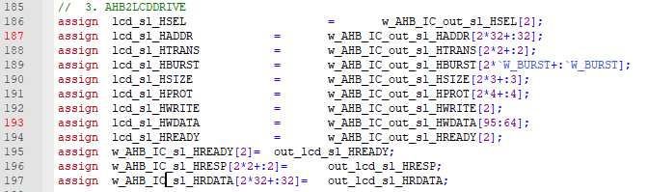

**(b) Generate data signals (lcd_drive_if.v)**

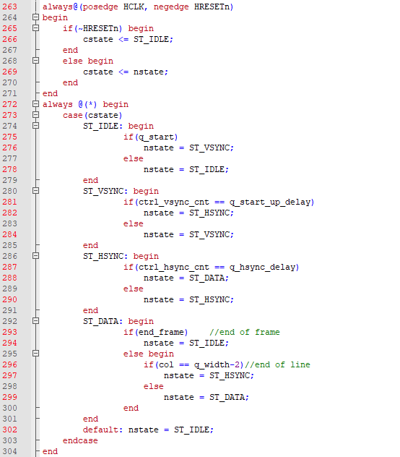

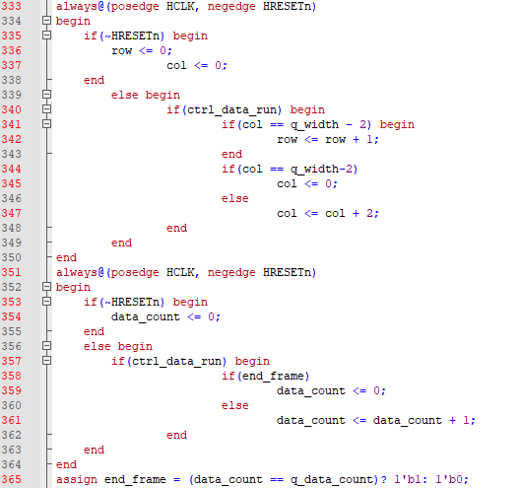

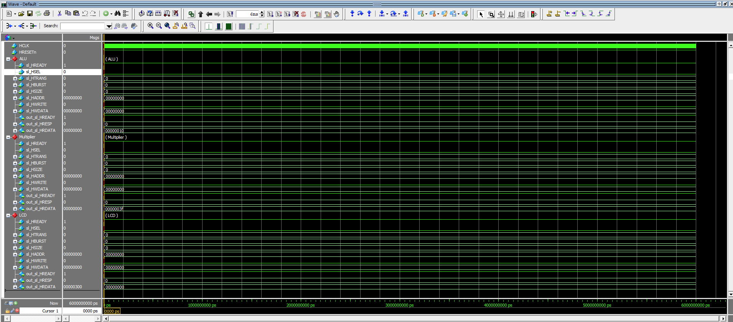

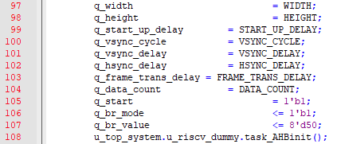

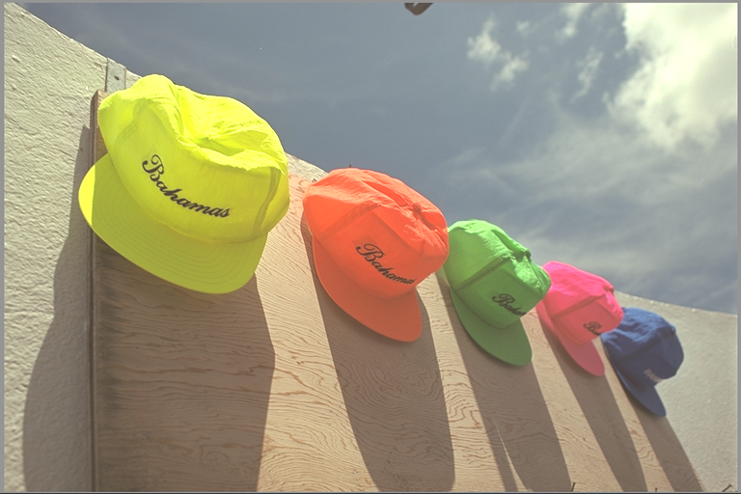

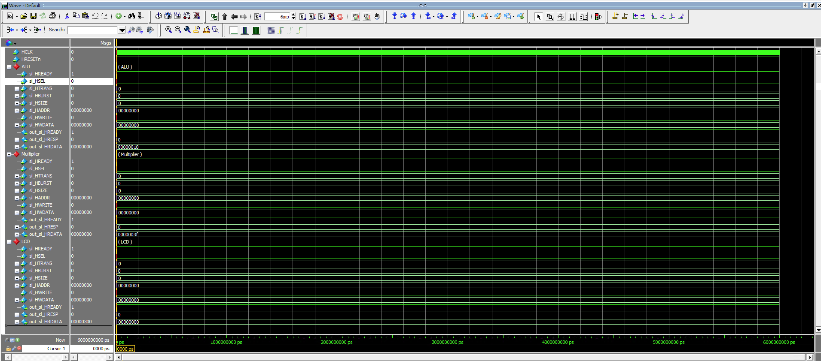

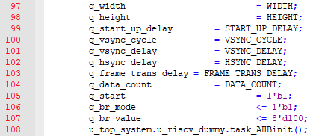

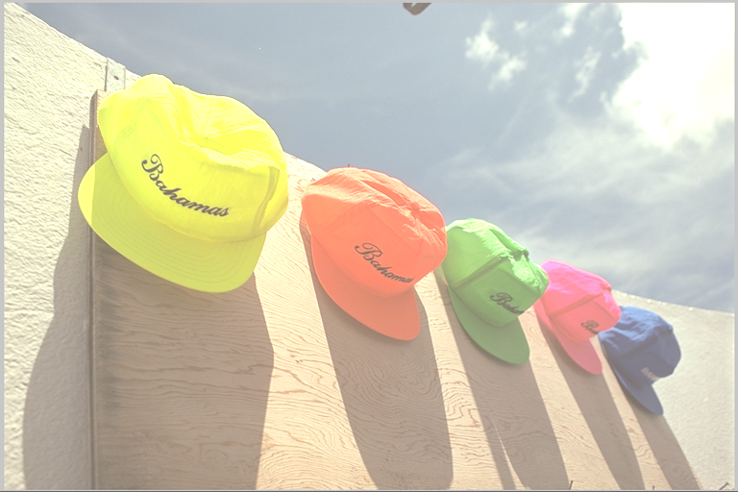

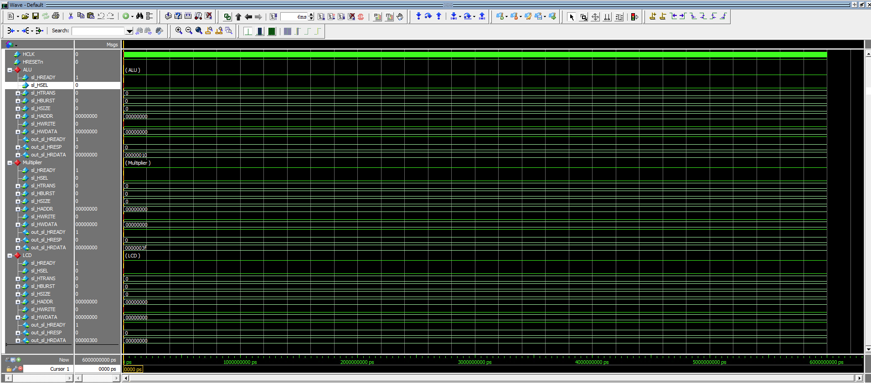

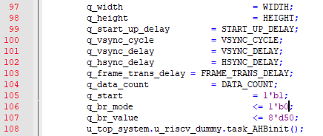

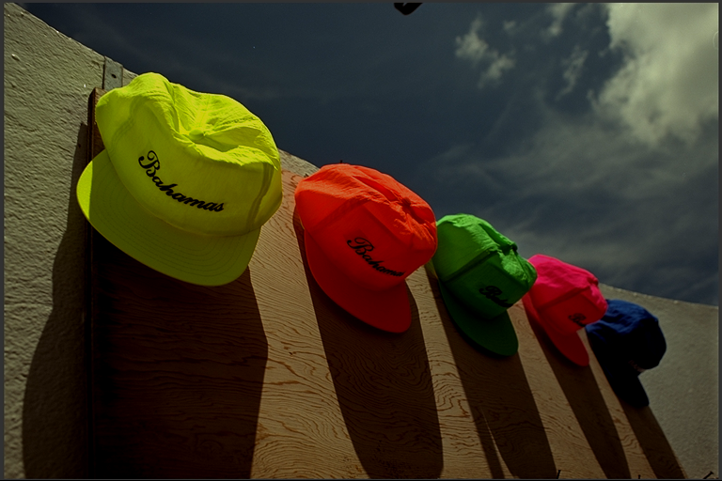

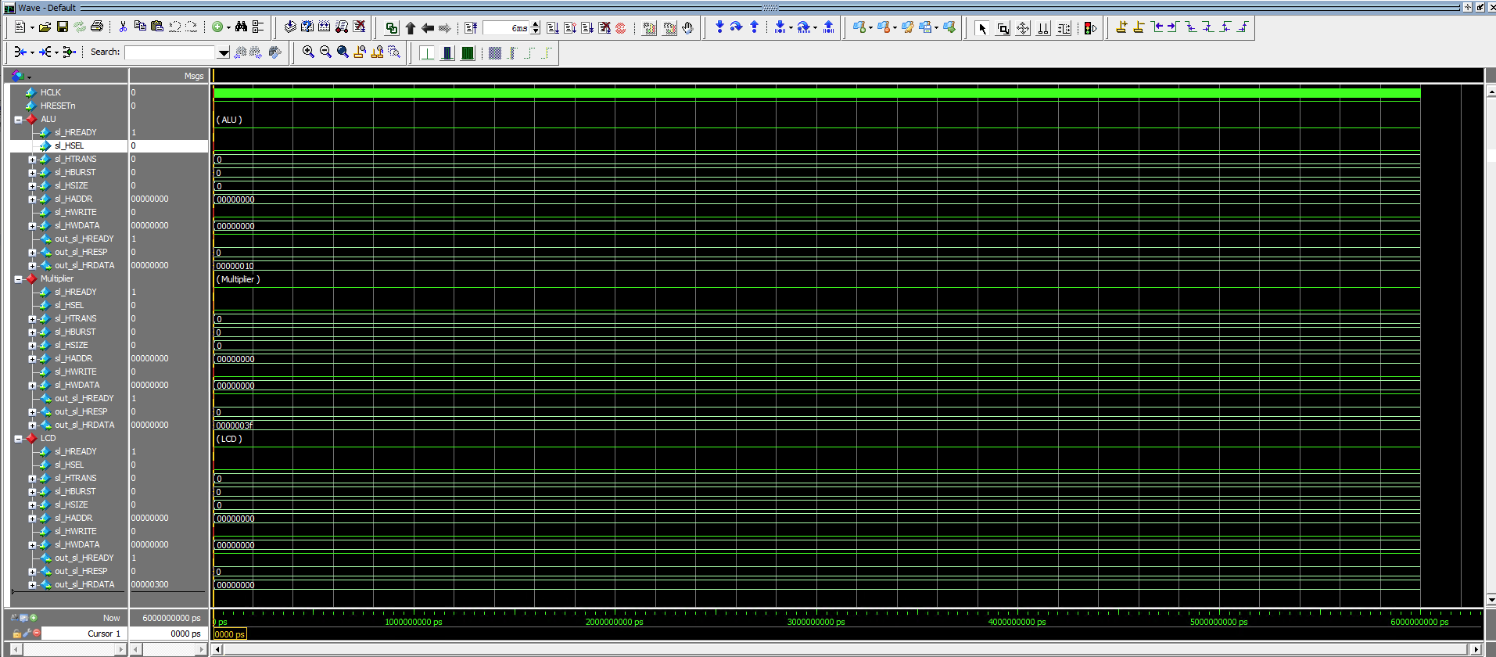

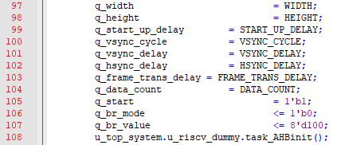

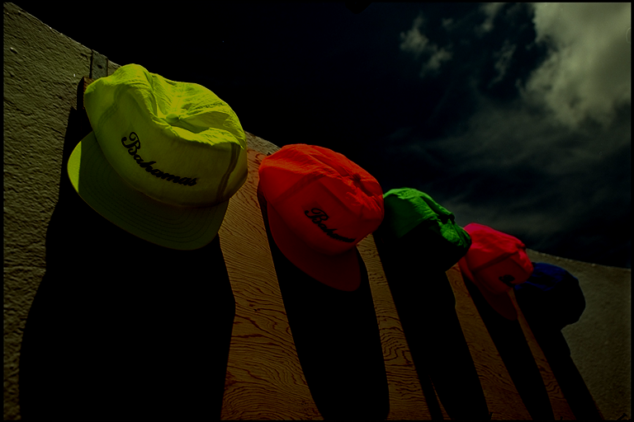

**Problem 2 (10p): BRAM Controller**

Implement an AHB interface of LCD Drive and integrate it into the top system. Please see the description in the lecture note for details.

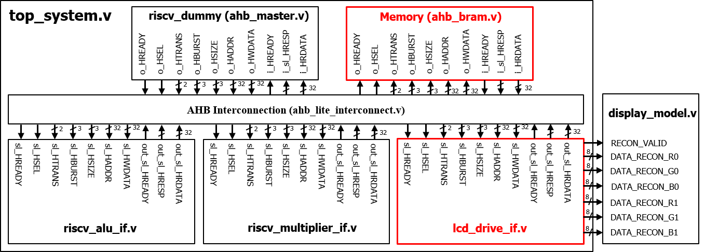

Fig. 2-1: A top system using an AHB bus.

What you have to do:

1. **Bus interface and IP integration (Similar to Problem 1)**

* Complete the code to create the AHB slave interface of the LCD drive (lcd_drive_if.v).
* Complete the code to add the LCD drive IP to the Bus interconnect (top_system.v).
* Do simulation with time = 5.000 ns
* Capture the simulation result, i.e., waveform.

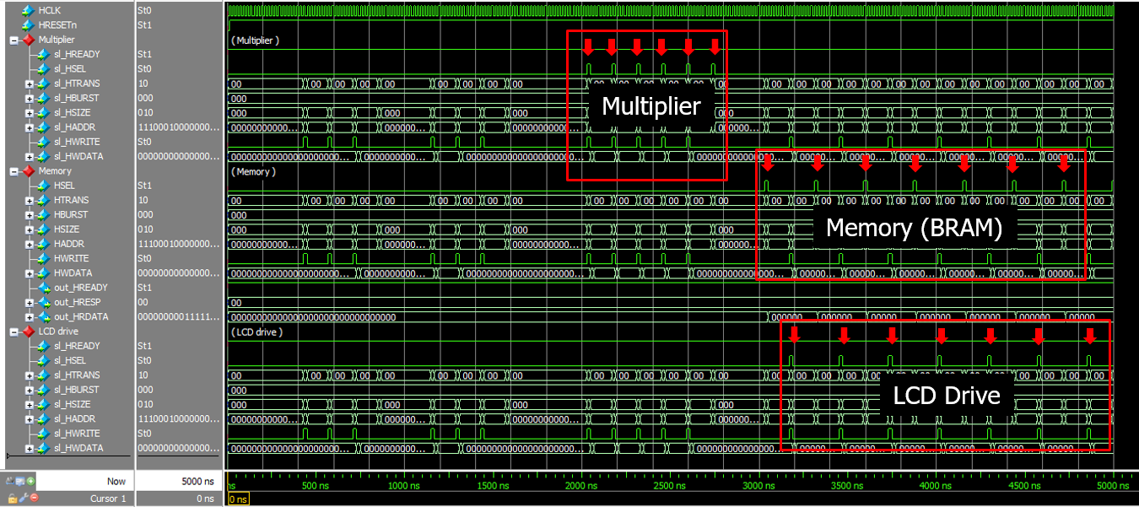

Fig. 2-2: Waveform with highlighted Select signals of three AHB slaves.

1. **Generate data signals (lcd_drive_if.v)**

* Complete the missing codes for data signals.
* Do simulation with time = 20 ms.
* Test the system with different modes.
* Capture the results, including the waveform and the output images.

**Submit your RTL codes**.

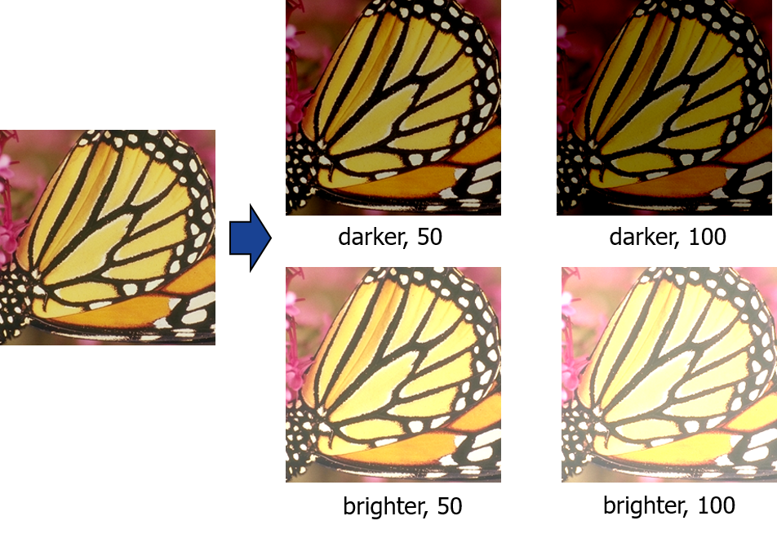

Fig. 2-3: Simulation results.

1. **Frame buffer**

* Explain the input and output signals of lcd_frame_buffer, i.e. size, meaning.
* What is the size of the frame buffer?

**Solution 2**

**(a) Bus interface and IP integration (Similar to Problem 1)**

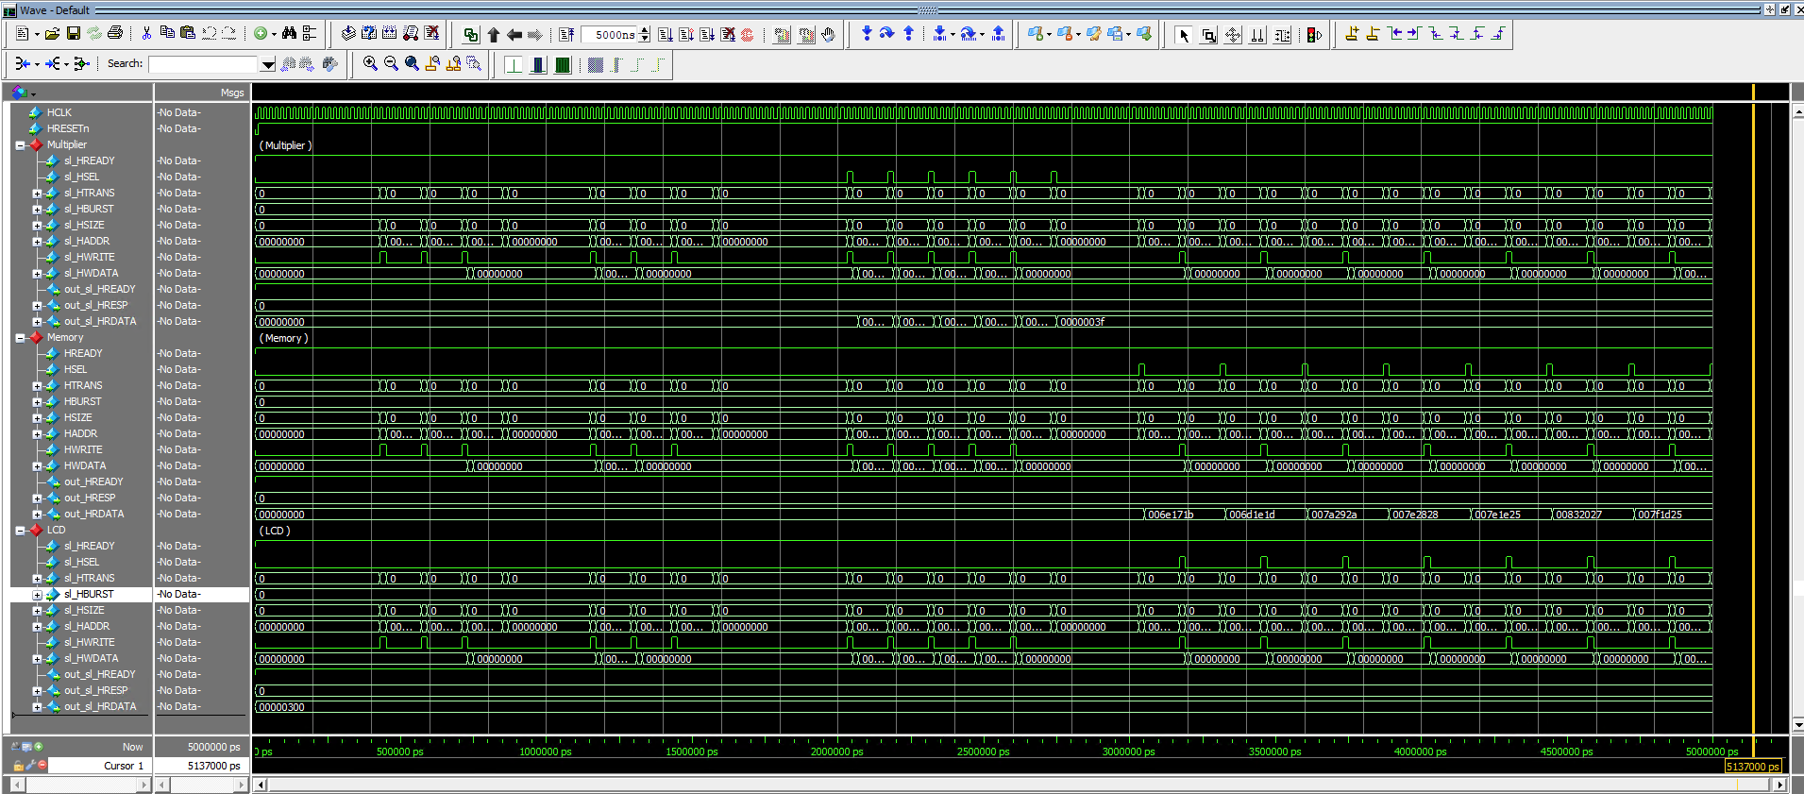

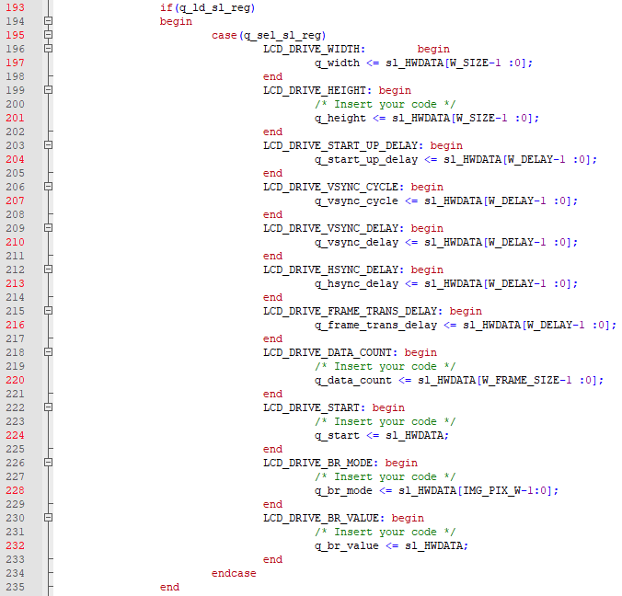

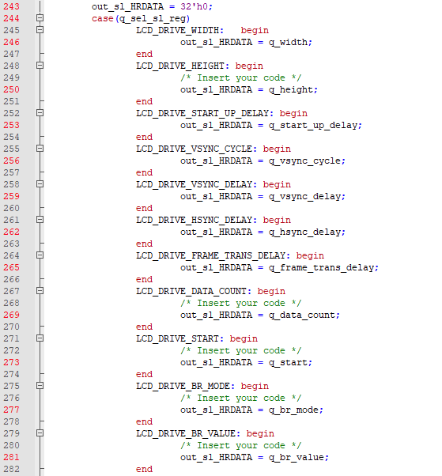

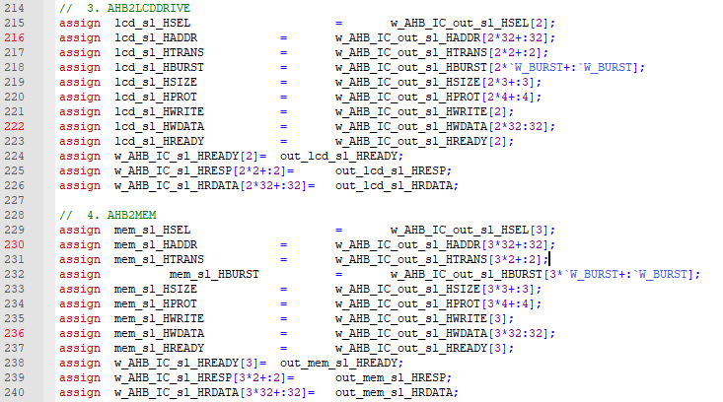

**(b) Generate data signals (lcd_drive_if.v)**

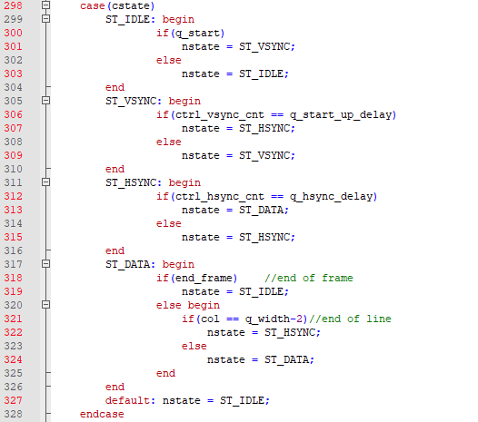

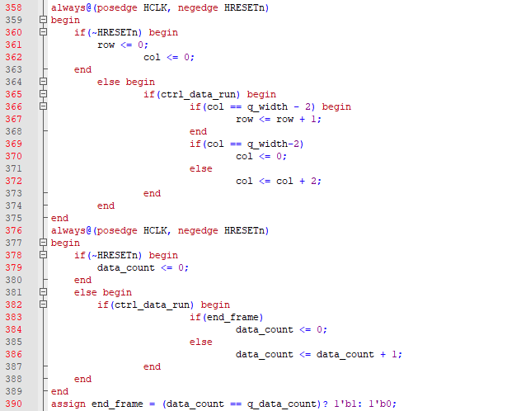

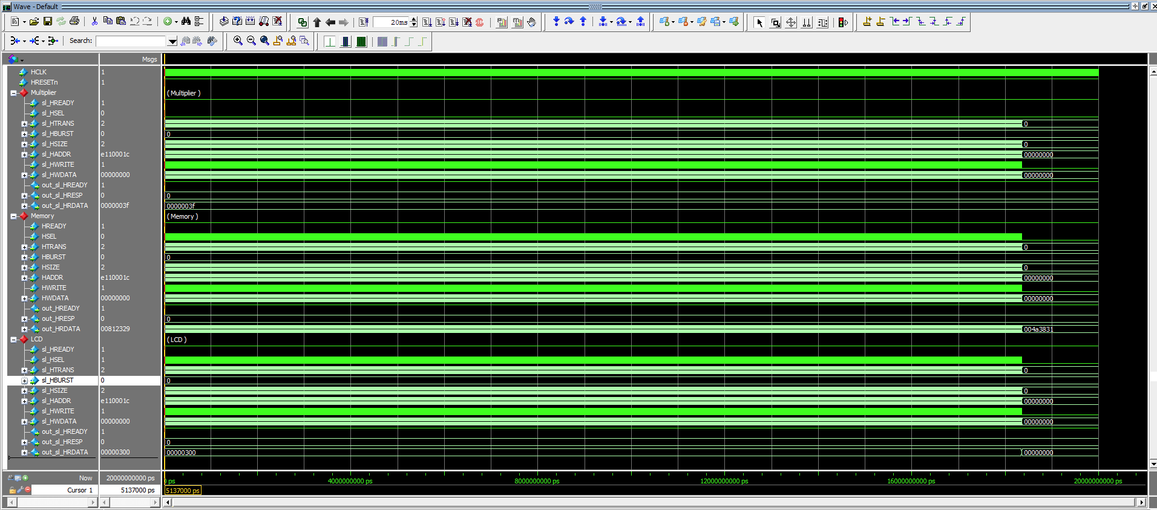

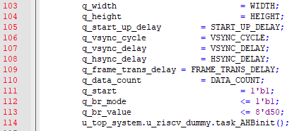

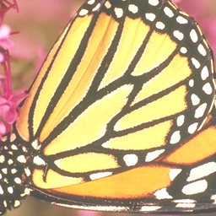

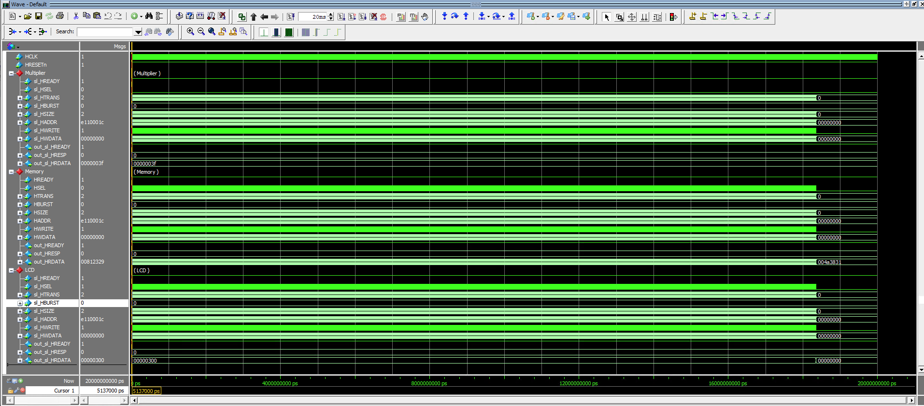

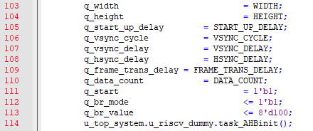



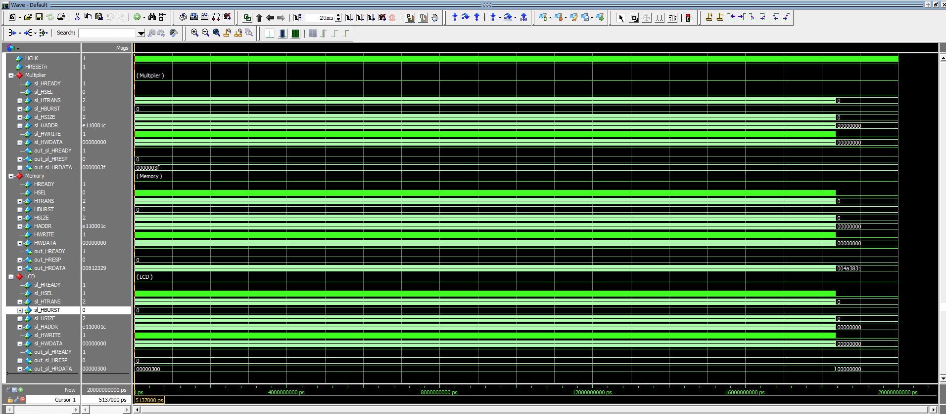

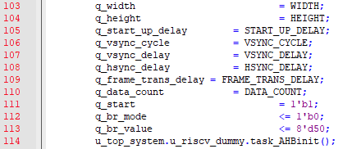

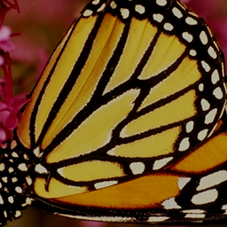

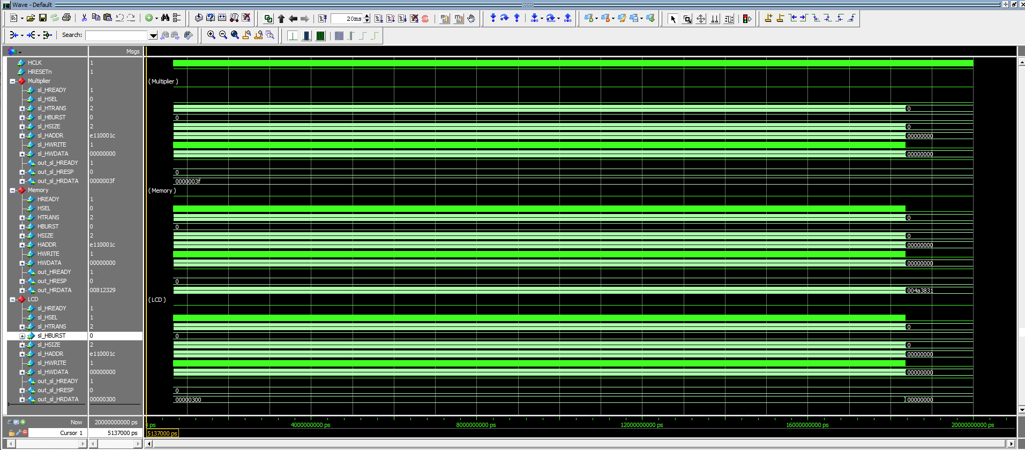

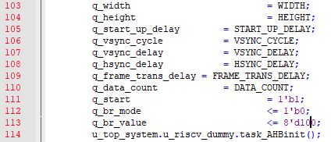



**(c) Frame Buffer**

1. Explain the input and output signals of lcd_frame_buffer, i.e. size, meaning.

Input clk : single bit, clock signal.

Input en : single bit, enable signal for selecting buffer to use.

Input addr : W_WORD bits, address for desired data. Address used in memory described as W_WORD wide.

Input cin : W_DATA bits, input data for store. Each address in memory store W_DATA wide data.

Input we : single bit, write enable for store data

Output dout : W_DATA bits, output data. Output W_DATA wide data in memory at address.

Input addr_dual_pixel : W_WORD bits, input address for first pixel of two pixels we wanted to get. Address used in memory described as W_WORD wide.

Output dout_dual_pixel : W_DATA bits, output data of two pixels. Retreive two pixel data from memory starting from given addr_dual_pixel, which is W_DATA wide.

2. What is the size of the frame buffer?

3 Channels, 8bits for each Channel and width and height -> total 24xWIDTHxHEIGHT bits

**Problem 3 (10p): Compressed frame buffer**

Implement an AHB interface of LCD Drive and integrate it into the top system. Please see the description in the lecture note for details.

1. **Bus interface and IP integration (Similar to Problems 1 and 2)**

* Complete the code to create the AHB slave interface of the LCD drive (lcd_drive_if.v).
* Complete the code to add the LCD drive IP to the Bus interconnect (top_system.v).

1. **Generate data signals (lcd_drive_if.v)**

* Complete the missing codes for data signals (lcd_drive_if.v).
* Complete the missing codes of RCT modules (lcd_forward_rct.v and lcd_inverse_rct.v).
* Do simulation with time = 20 ms.
* Test the system with different modes.
* Capture the results, including the waveform and the output images.

**Submit your RTL codes**.



Fig. 3-1: Simulation results.

1. **Frame buffer**

* Explain the input and output signals of lcd_frame_buffer_opt, i.e. size, meaning.
* What is the size of the frame buffer?
* Compare the original frame buffer sizes in Problem 2 and the compressed buffer sizes in Problem 3.

**Solution 3:**

**(a) Bus interface and IP integration (Similar to Problems 1 and 2)**

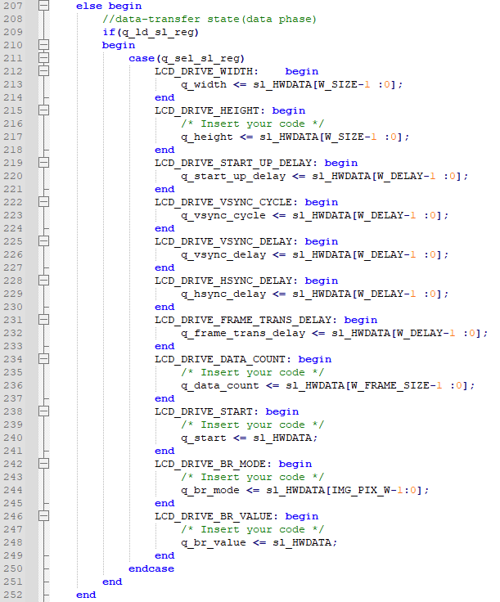

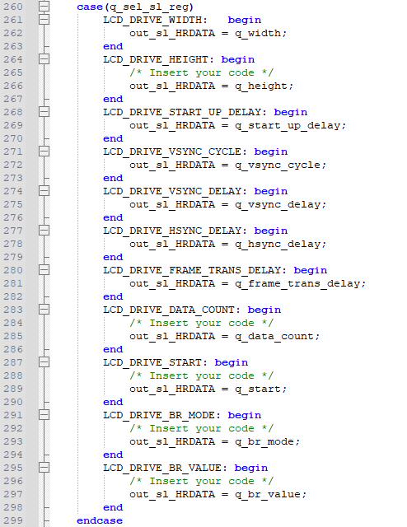

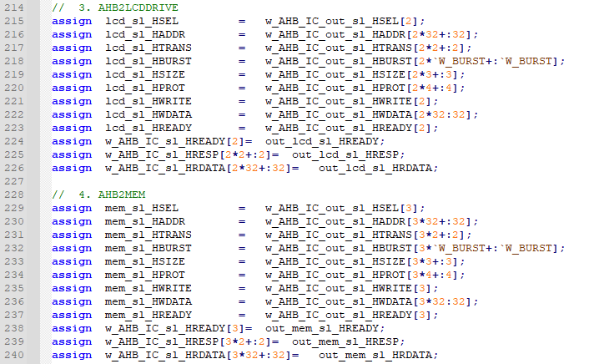

**(b) Generate data signals (lcd_drive_if.v)**

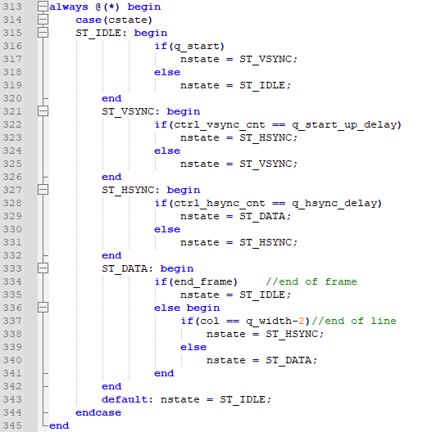

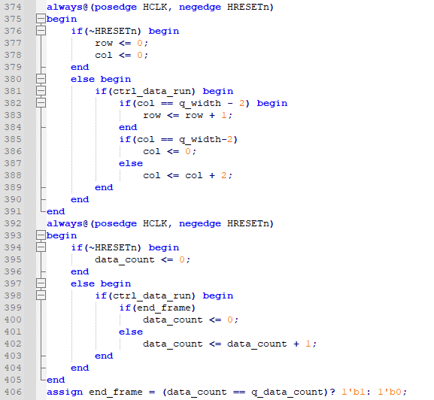

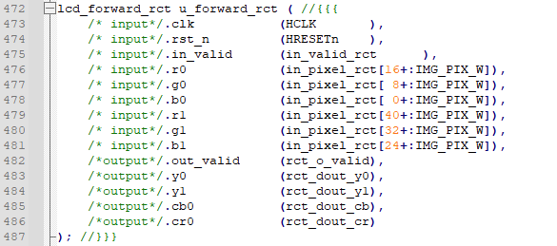

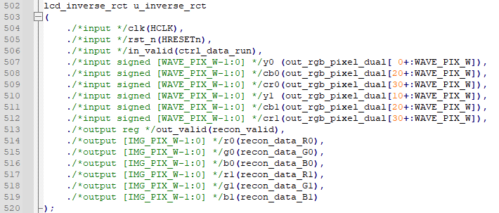

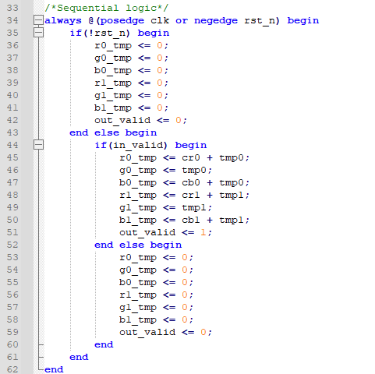

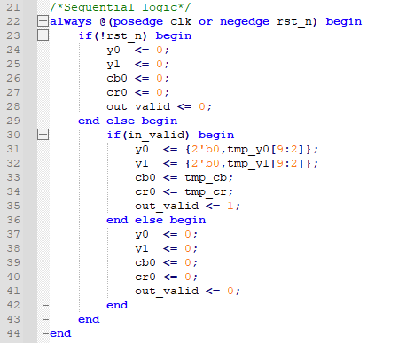

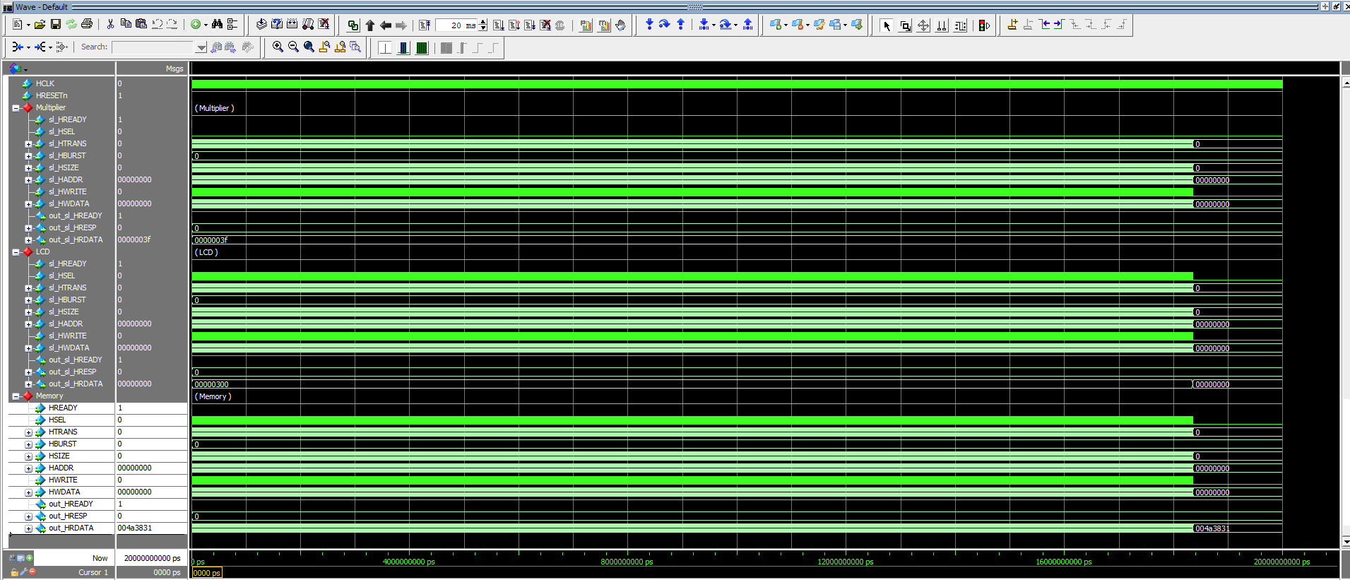

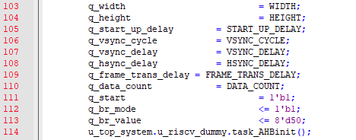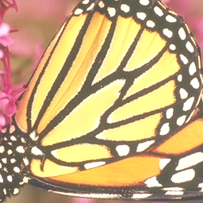

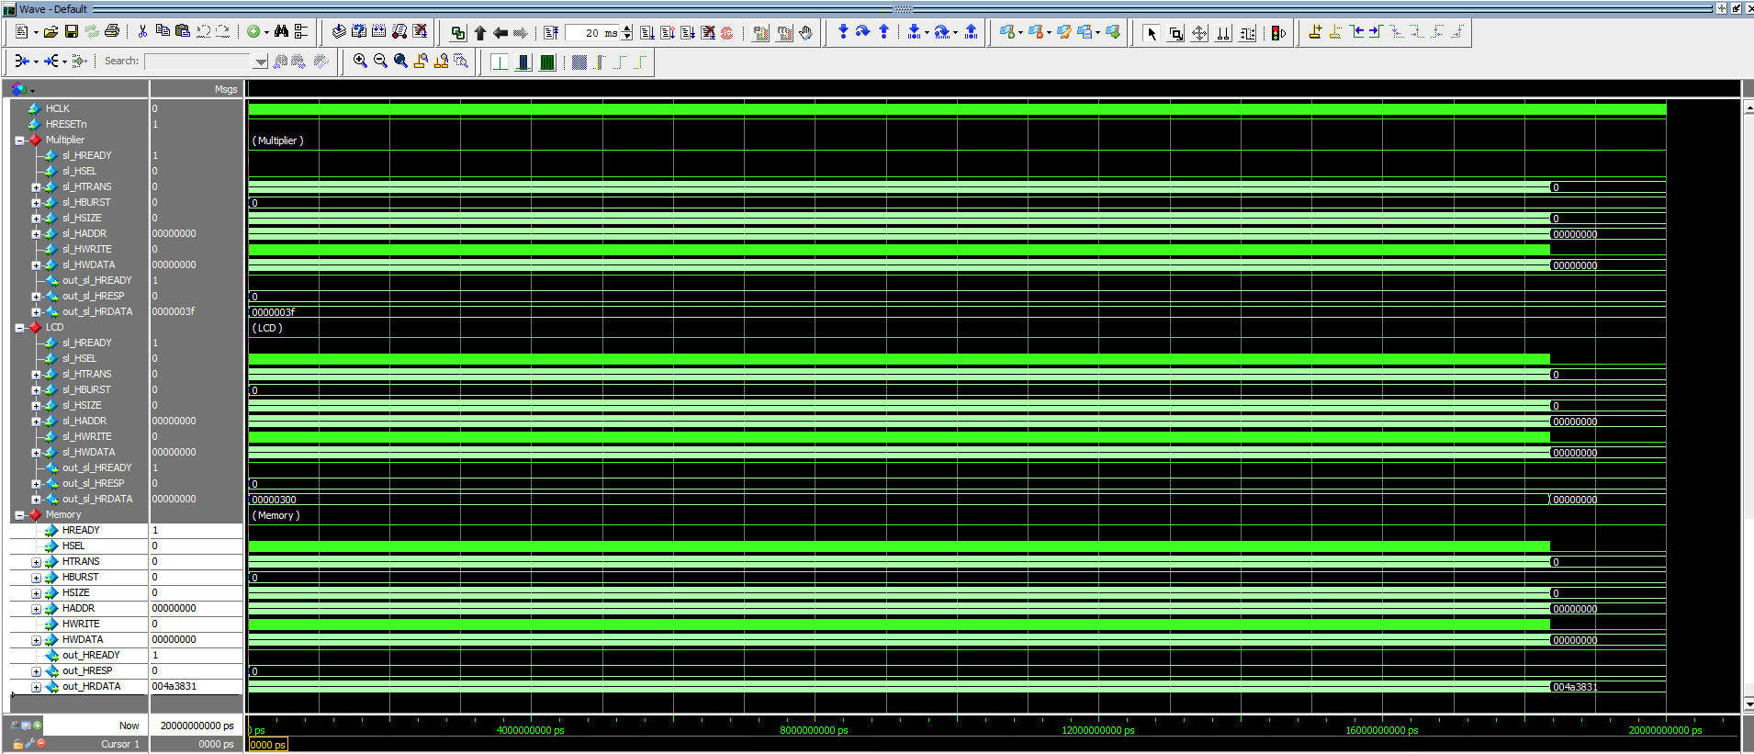

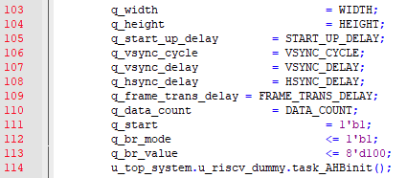

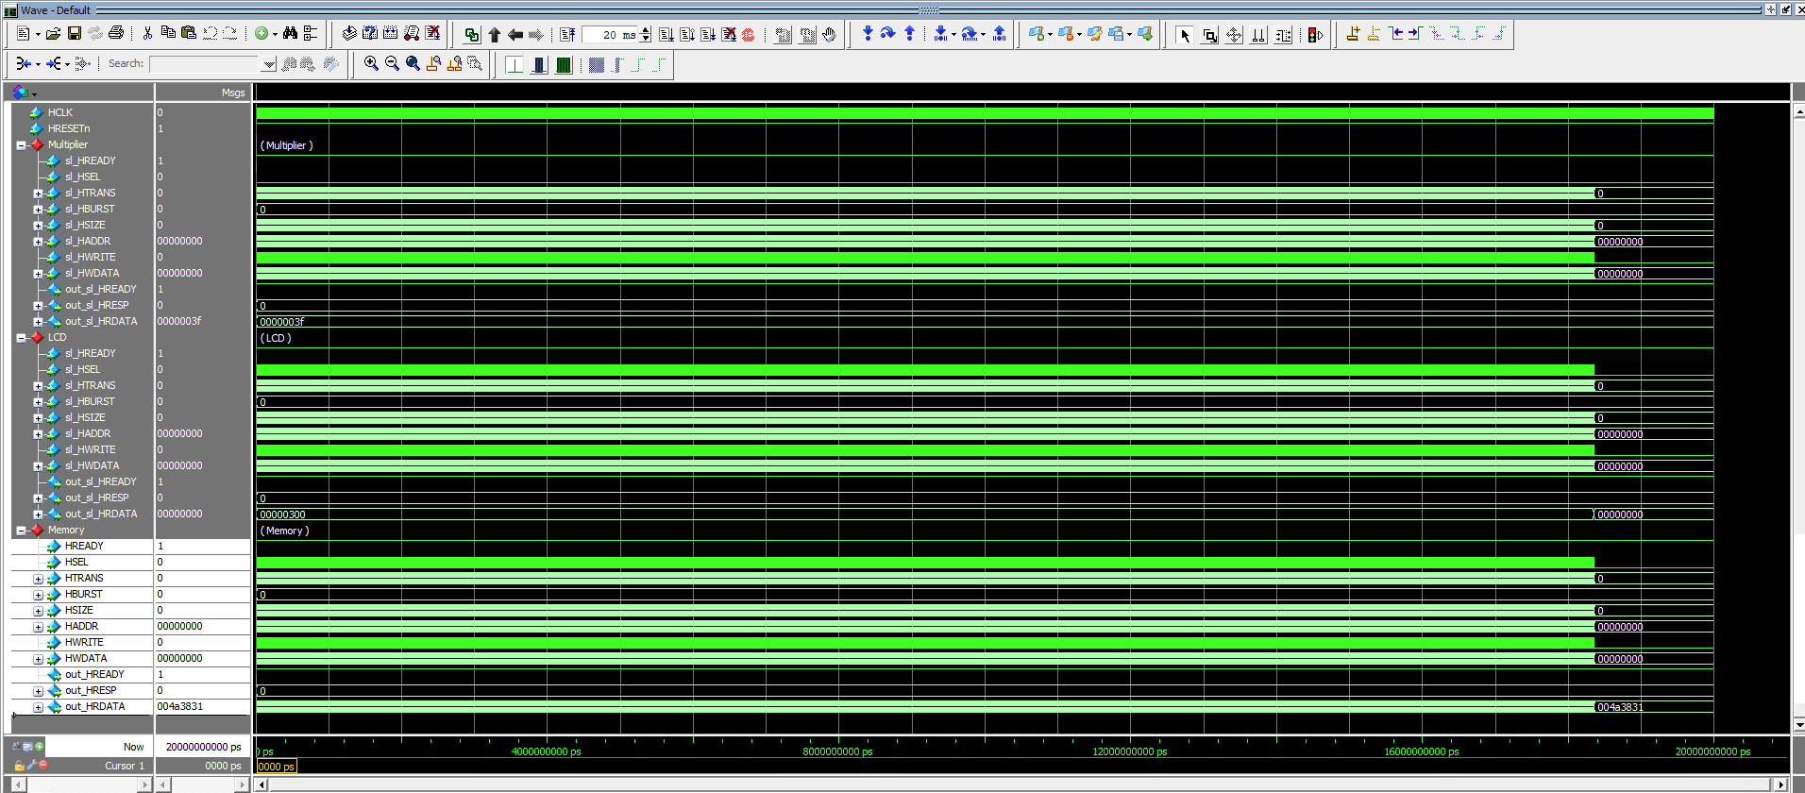

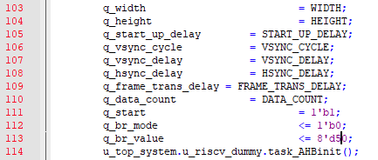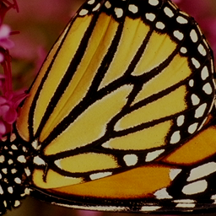

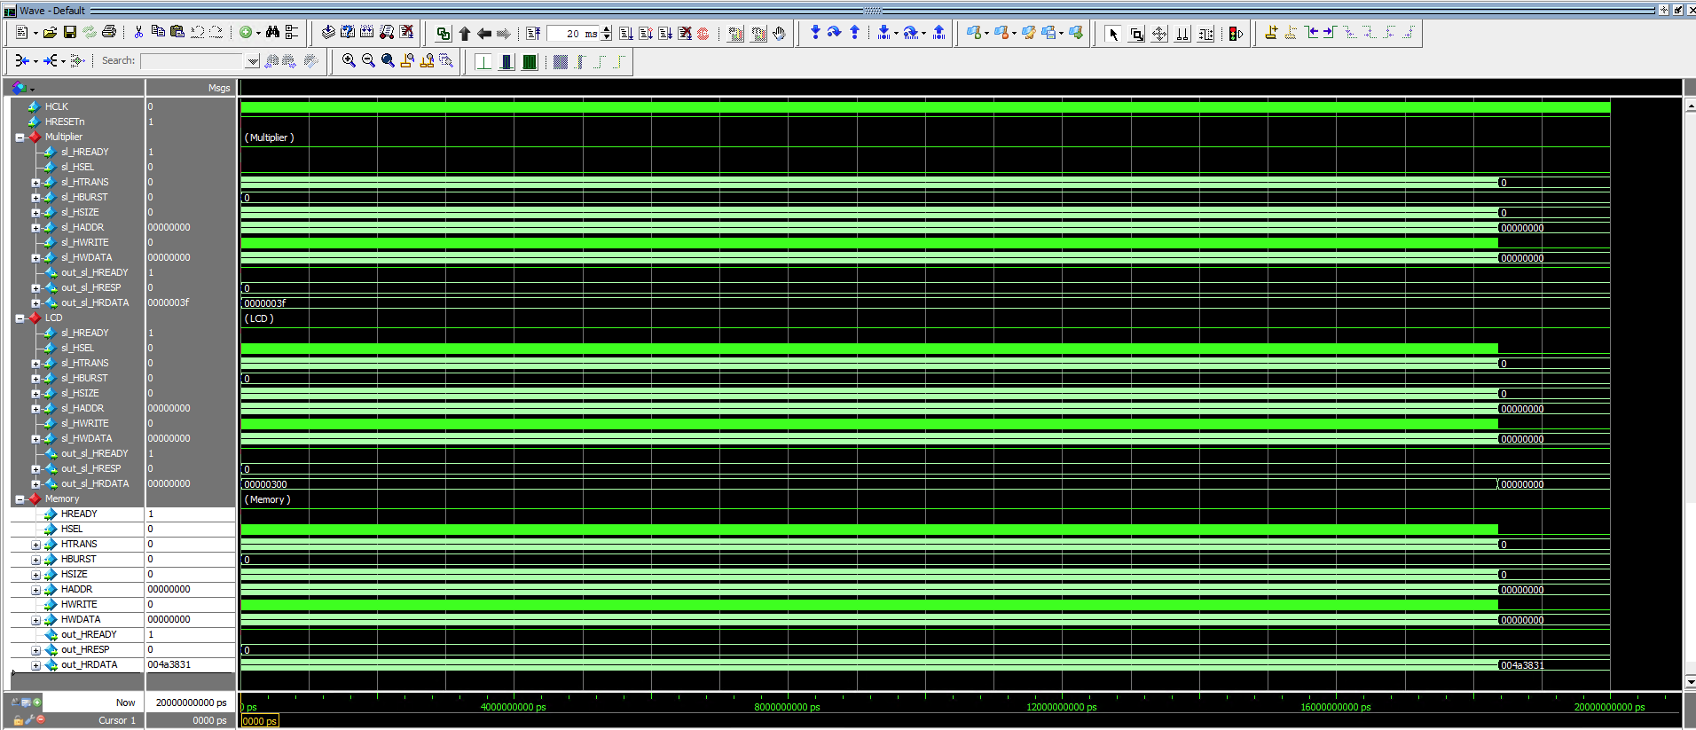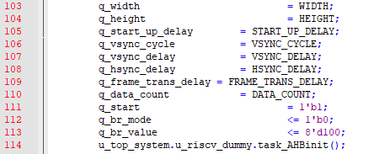

**(c) Frame buffer**

1. Explain the input and output signals of lcd_frame_buffer_opt, i.e. size, meaning.

Input clk : single bit, clock signal.

Input en : single bit, enable signal for selecting buffer to use.

Input addr : W_WORD bits, address for desired data. Address used in memory described as W_WORD wide.

Input cin : W_DATA bits, input data for store. Each address in memory store W_DATA wide data.

Input we : single bit, write enable for store data

Output dout : W_DATA bits, output data. Output W_DATA wide data in memory at address.

Input addr_dual_pixel : W_WORD bits, input address for first pixel of two pixels we wanted to get. Address used in memory described as W_WORD wide.

Output dout_dual_pixel : W_DATA bits, output data of two pixels. Retreive two pixel data from memory starting from given addr_dual_pixel, which is W_DATA wide.

2. What is the size of the frame buffer?

4 10bits data per two pixels -> 4x10xWIDTHxHEIGHT/2 = 20xWIDTHxHEIGHT

3. Compare the original frame buffer sizes in Problem 2 and the compressed buffer sizes in Problem 3.

Compressed buffer size is 16.67% reduced from original frame buffer size. (24xWIDTH xHEIGHT -> 20xWIDTHxHEIGHT)